**summary of the vorágine**

Arturo Cova tells us his story and that of Alicia. Alice was doomed to marry an old but rich landowner. She decides to have an affair with Arturo Cova, a cultured, womanizing and poor poet, hoping that this will save her from marriage.

But Alicia's fiancé condemns Arturo to prison, and the pair of lovers decide to flee to Casanare. There they find friends who welcome and help them: Don Rafo, and the couple Griselda and Fidel Franco.

Franco, who has a foundation, pawns it with the promise that Zubieta, the owner of a large herd with a lot of cattle, will sell him 1,000 cattle at a discount, but in exchange he must take them. This turns out to be a lie by Zubieta in order to get rid of Barrera, a rubber tapper who promised gold and riches, seeking to convince everyone to follow him in rubber exploitation. Among these people is Griselda, whom Barrera sought to convince with sweet promises and gifts.

Griselda and Alicia, who usually went out alone, often found Barrera. Arturo explodes in jealousy at the possibility that Alicia is unfaithful to him with Barrera, gets drunk and decides to flee to Zubieta's ranch. There he confronts Barrera, who shoots him in the shoulder.

Arturo goes out with the mulatto Correa after Franco to catch the bulls, but upon his return he discovers that Barrera has ordered Zubieta to be murdered. Barrera brings in a corrupt judge, and forces the other workers to witness that the crime was committed by Arturo and Franco.

They both discover that Griselda and Alicia have abandoned them. They explode in anger, madness and euphoria, they set the plains on fire

Arturo Cova, Franco, Correa and Pipa flee to Vichada. Different indigenous tribes are found there. There are the aborigines of the hut, described as docile, cunning and distrustful, who supply them for the trip.

Then they found the nomadic tribe of the Guahibos. They are described as a naive, superstitious and rudimentary tribe. Arturo and his comrades are welcomed by the tribe, which bids them farewell with a great party to the rhythm of drums, dances and fermented chicha.

Upon resuming their trip, they coincidentally meet Helí Mesa, who had been under the command of Fidel Franco when he was still part of the army.

Helí told how he was deceived by Barrera and how he had betrayed all the men and women who followed him. He had made them hand over all their possessions and left them as slaves under the rule of two of his comrades. They chained them and threw a baby to the alligators.

In the midst of these abuses, Helí takes the opportunity to escape along with two Maipireño Indians. The fugitives decide to continue towards Vaupés, seeking revenge on Barrera. The Maipireños perish in one of the river's strong waterfalls. El Pipa runs away with the Guahibo Indians.

In Guaviare they find the old rubber tapper Clemente Silva. The old man, who is very sick, has his legs full of sores, and, among the sores, worms. He has suffered all kinds of abuse for 16 years. His back is covered with scars from whippings. The old man says that he is originally from Pasto, and he went out in search of his 12-year-old son, who had fled with the rubber tappers. After having been looking for it for eight years, during which he himself was a rubber tapper and a slave, he found it already buried.

Cova and his companions continue their path together with Clemente Silva. They propose to collect the bones of Silva's son, which were confiscated by Cayeno, and then continue with their revenge.

Clemente Silva continues narrating how he changed owners from rubber grower to rubber grower. Silva sought to stay near his son's grave, in the Brazilian jungles, until he could exhume his bones. During this time he was lost for two months in the jungle, during which he lost his mind and his companions perished.

Cova and his companions arrive to see the madonna, Zoraida Ayram, who asks that they "betray" Cayeno in the name of a debt he owes her.

There they find Ramiro Estévanez, an old friend of Cova, and Váquiro, who witnessed the massacre of San Fernando del Atabapo, under the rule of Colonel Funes. Cova, to gain the favor and trust of the Madonna, becomes her lover.

Cova and his companions find Griselda, who was acquired by the Madonna, and brings news of Alicia. He assures that Alicia was always faithful to Arturo, and is still Barrera's slave.

Arturo finally manages to reunite with Alicia, and fighting defeats Barrera. Alicia gives birth to a seven-month-old boy, Arturo's son, and fearing that the newborn will catch some plague, everyone flees to the jungle

She remembers her husband running away with his friend!

**Comic**

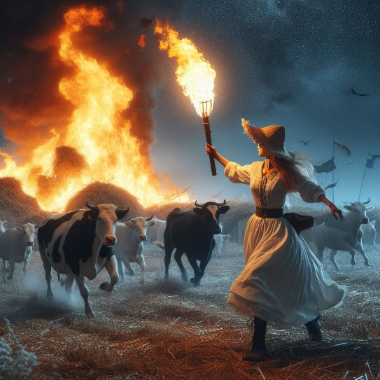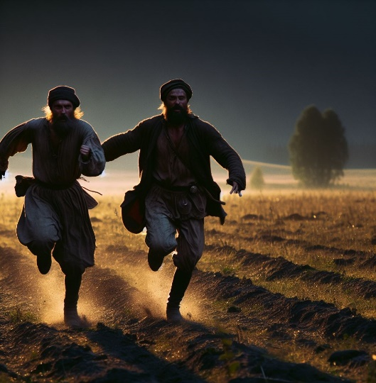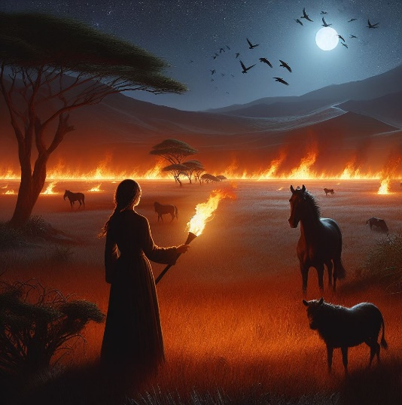

**muuu!**